Organisation Name (if applicable): |  |  |  |  |  | Contact / responsible person on the day:
Name:

Mobile:

Email:
Name of Event (for signage): |  |  |  |  |  | Name:  Mobile:  Email:
Type of Event: |  |  |  |  |  | Accounts details:
Name:

Address:

:
Charity |  | Yes |  | No |  | Name:  Address:  :
Charity Number: |  |  |  |  |  | Name:  Address:  :

Date(s) and time(s)  Minimum of two hours and must include set up and clearing away within booking time. |  |  |  | From |  |  | To
 |  |  |  | From |  |  | To
 |  |  |  | From |  |  | To
 |  |  |  | From |  |  | To
All prices shown are inclusive of VAT – VAT will be charged at standard rate unless the hirer certifies they are a charity fulfilling their charitable objective.
Expected numbers attending: |  | Category A  Public meetings, charities, local non-profit organisations or amateur groups and exhibitions. |  |  |  | Category B  Private functions, commercial and business bookings.
 |  | Cost per hour | Please tick |  |  | Cost per hour |  |  | Please tick
Chamber Room – Maximum of 60 people
Weekdays (9am-5pm) |  | £22.01 |  |  |  | £28.78
Weekdays (5pm-midnight) |  | £28.78 |  |  |  | £33.86
Saturday |  | £43.34 |  |  |  | £50.79
Sunday/Bank Holidays |  | £55.87 |  |  |  | £60.94
Elsie Kimber Room – Maximum of 12 people
Weekdays (9am-5pm) |  | £13.54 |  |  |  | £18.62
Weekdays (5pm-midnight) |  | £23.02 |  |  |  | £28.78
Saturday |  | £32.50 |  |  |  | £33.86
Sunday/Bank Holidays |  | £52.50 |  |  |  | £55.87
Please complete page 2

Additional Facilities (please tick):
Kitchen use |  | Projector/Screen (Chamber only) £24.50
TV (Elsie Kimber only) £12.50 |  | Hybrid Conference Facility (projector/screen included) £41

Chamber Layout Requirement:
Please view our website for photos of the different layout styles: https://www.newbury.gov.uk/services/hire-town-hall/
Large Square | Square | Long Boardroom  (Max 25) | Theatre Layout  (Max 50) | U Shape  (Max 25)

Notes:

I agree to hire the premises under the conditions set out in the additional document, to pay the appropriate charges for the hire, and when regular hires or large public events, to provide evidence of Public Liability Insurance Cover.
I agree to ensure a nominated person is responsible for the delivery of the emergency evacuation procedure to our group.
Name (printed) ………………………… Signature ………………………… Date ………/…………/………
Once completed please return a copy to Newbury Town Council, Town Hall, Market Place, Newbury, Berkshire, RG14 5AA or email amy.xing@newbury.gov.uk

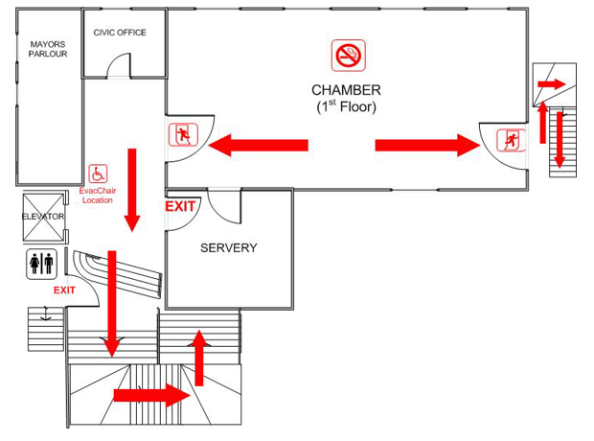

PLEASE ENSURE THAT ALL STAFF AND VISITORS ARE AWARE OF THIS EVACUATION PROCEDURE

EMERGENCY EVACUATION PROCEDURES
COUNCIL CHAMBER
The FIRE ALARM is a continuous ring
On hearing the alarm:
- Leave the building by the nearest safe exit.
- Your nominated person/fire marshal must check all toilets and other areas to ensure that all persons in your group are clear of these areas.
- Do not collect personal belongings.
- Close internal doors.
- Assemble in the Market Place outside the Cancer Research Charity Shop.
- Take a roll call of all persons under your control.
- Do not re-enter the building until advised to do so by a Fire Officer. In the event of a drill, permission will be given by a Fire Marshal or Officer of Newbury Town Council.

FIRE ALARM TESTING
The Fire Alarm will be tested every Monday (or the first working day after Bank Holidays) between 5.00pm and 5.15pm.

